CRUTCH WALKING INSTRUCTIONS

Safety TIPS:

- Secure the arm pads and hand grips prior to use.
- Tighten all hardware (screws and wing nuts) at least once per week.
- Clean the crutch tips of pebbles and dirt to minimize slipping.
- Have someone assist you until you master the technique of crutch use.
- Remove loose rugs and electrical cords from all potential paths to avoid tripping and falling.
- Replace crutch tips if they should wear out.
- Be careful on wet indoor surfaces which may be extremely slick.
- When standing on crutches, place them a short distance in front of your feet and lean forward slightly.
- Never stand with the crutches even with your body, as you can lose your balance either forward or backward in this position.
- Keep body weight on your wrists/hands, never your underarms.
- It helps to have a buddy walk with you during the day, to open doors and help carry your school supplies.
- Always wear backpack on BOTH shoulders.
- Always wear shoes – never slippers or flip flops as they will affect your balance.

To walk with Crutches:

- Put your crutches under your arms and press them against your body.
- Bear your weight on your hands, not under your arms.
- Place the crutches ahead of you approximately 12 inches.
- Push down on the grips as you step slightly past the crutches, leading with the GOOD LEG.
- Advance the crutches forward approximately 12 inches; then continue.
- Move slowly at first until a natural pattern is achieved.
- It’s important to use crutches correctly. If any numbness or tingling is felt in your armpits or upper arms, ensure you are using proper technique.
- Follow the directions from your physician on whether you should be non-weight bearing or partial-weight bearing while on the crutches.

To sit down:
- Stand with chair 2-3 inches behind legs.
- Put both crutches in your hand on the
affected side, reach backwards for the
chair or seat with the other hand.
- Lower yourself slowly into the chair,
bending at the hips.

To get up from a seated position:
- Reverse this process
- Hold both crutches on affected side.
- Slide to the edge of the chair or seat.
- Push down on the arm of the chair on
the good side.
- Stand up, and then put the crutches
under your arms.
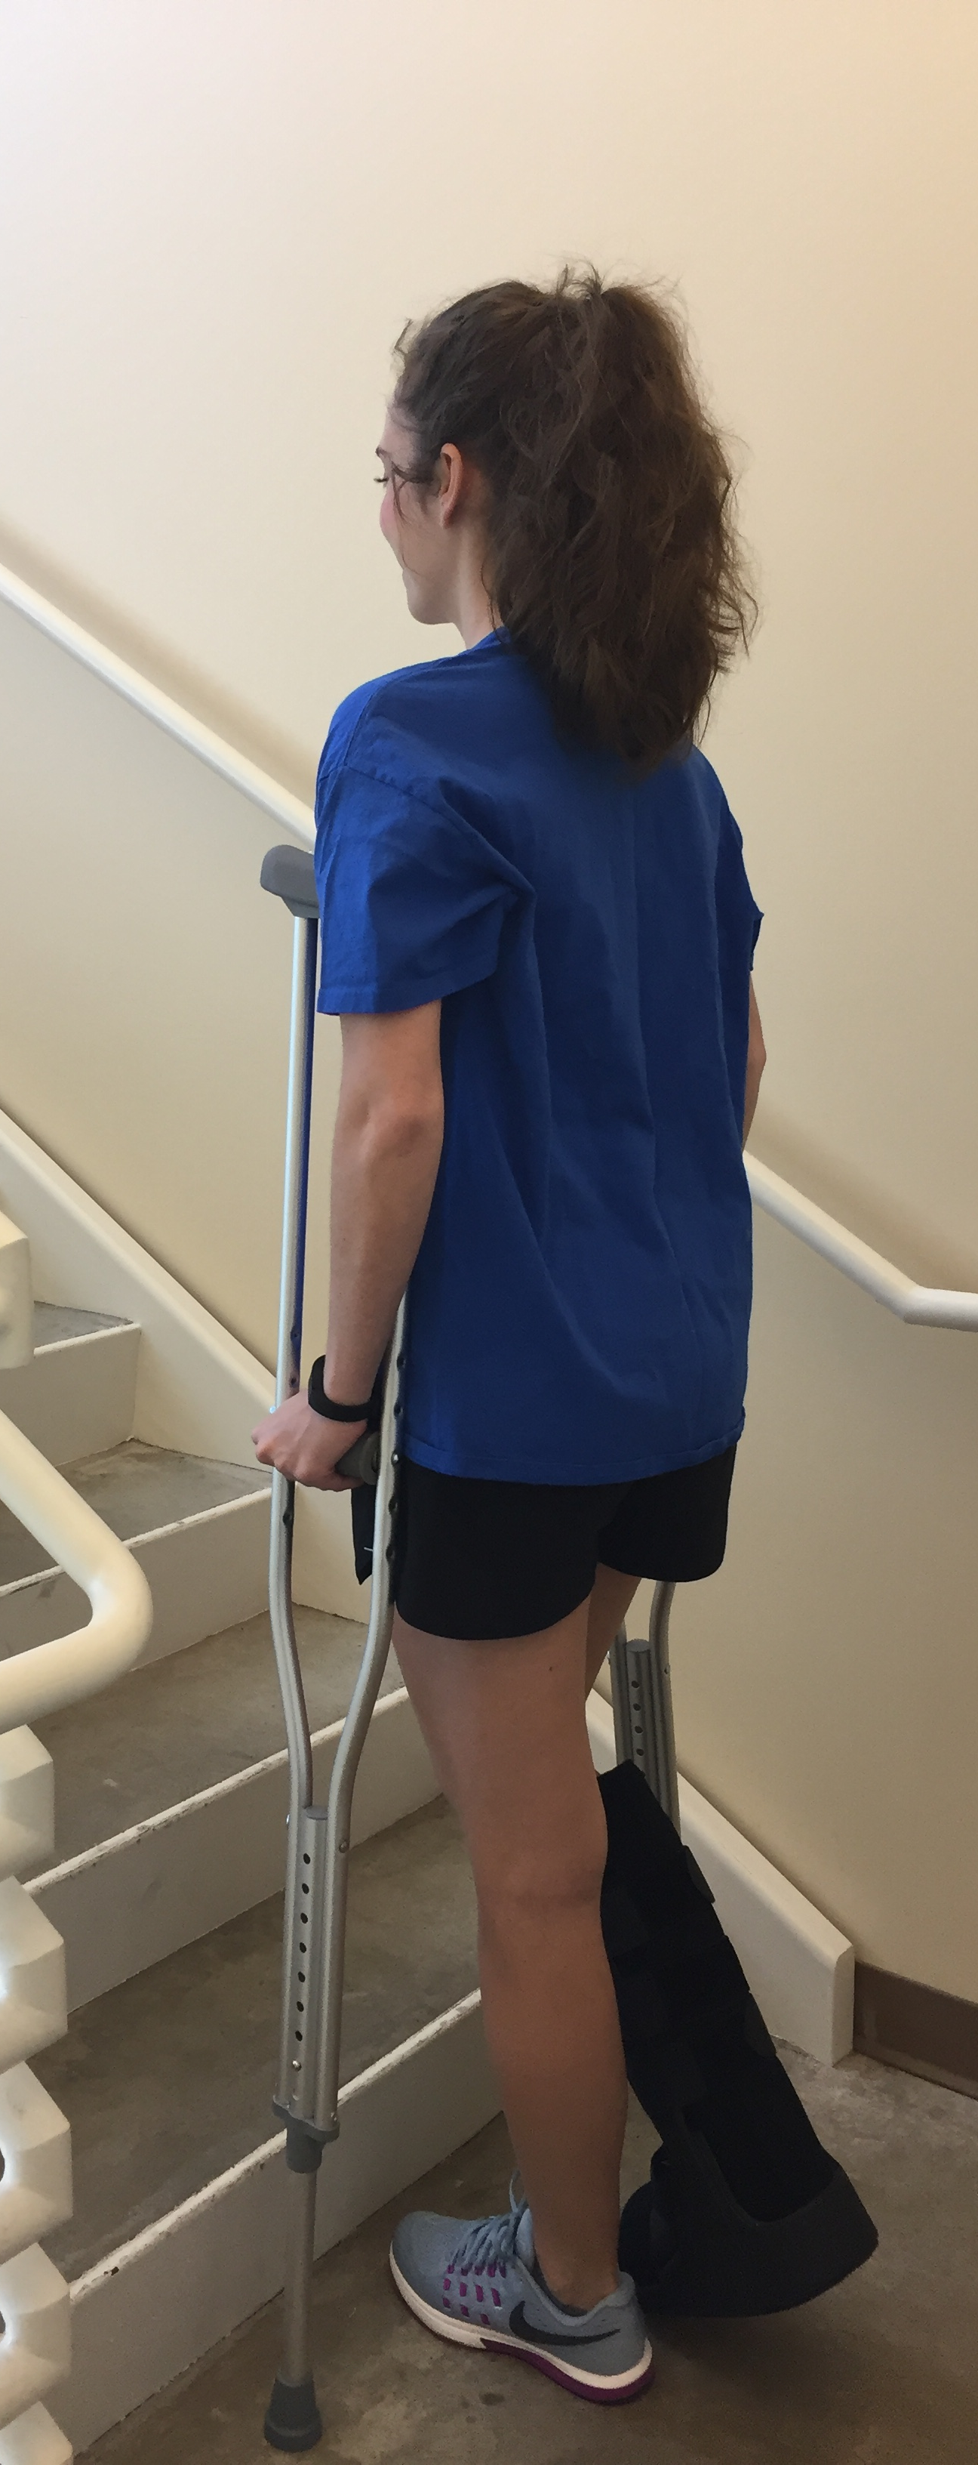
- Press the arm pads into the body.

To go upstairs:
- Start close to the bottom step, and push down on the
crutches with your hands.
- Step up first with the “good” foot, then the injured
leg followed by the crutches.
- Take one step at a time.
- Have someone walk behind you to provide support (or use
elevator)

To go down stairs:
- Start at the edge of the step, keeping your hips beneath
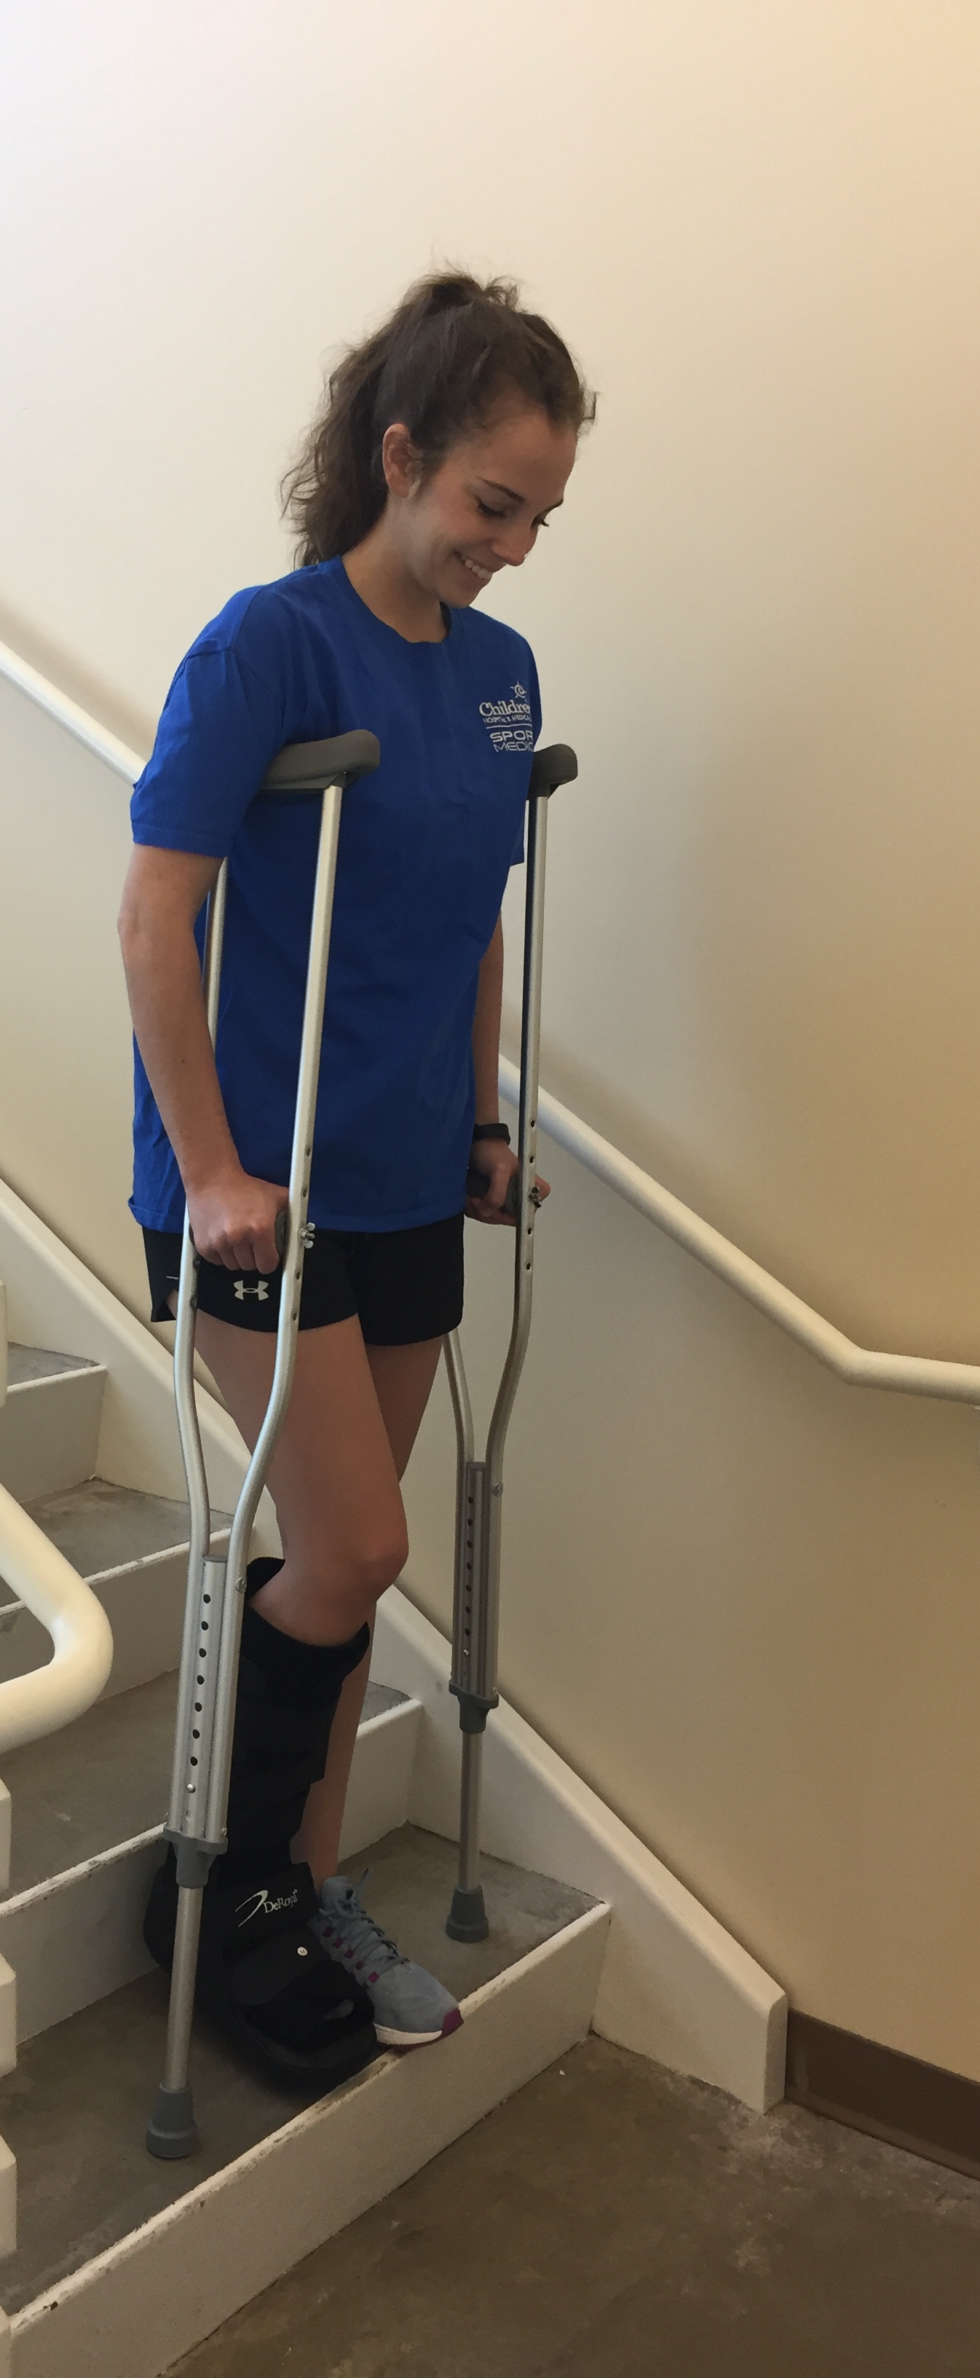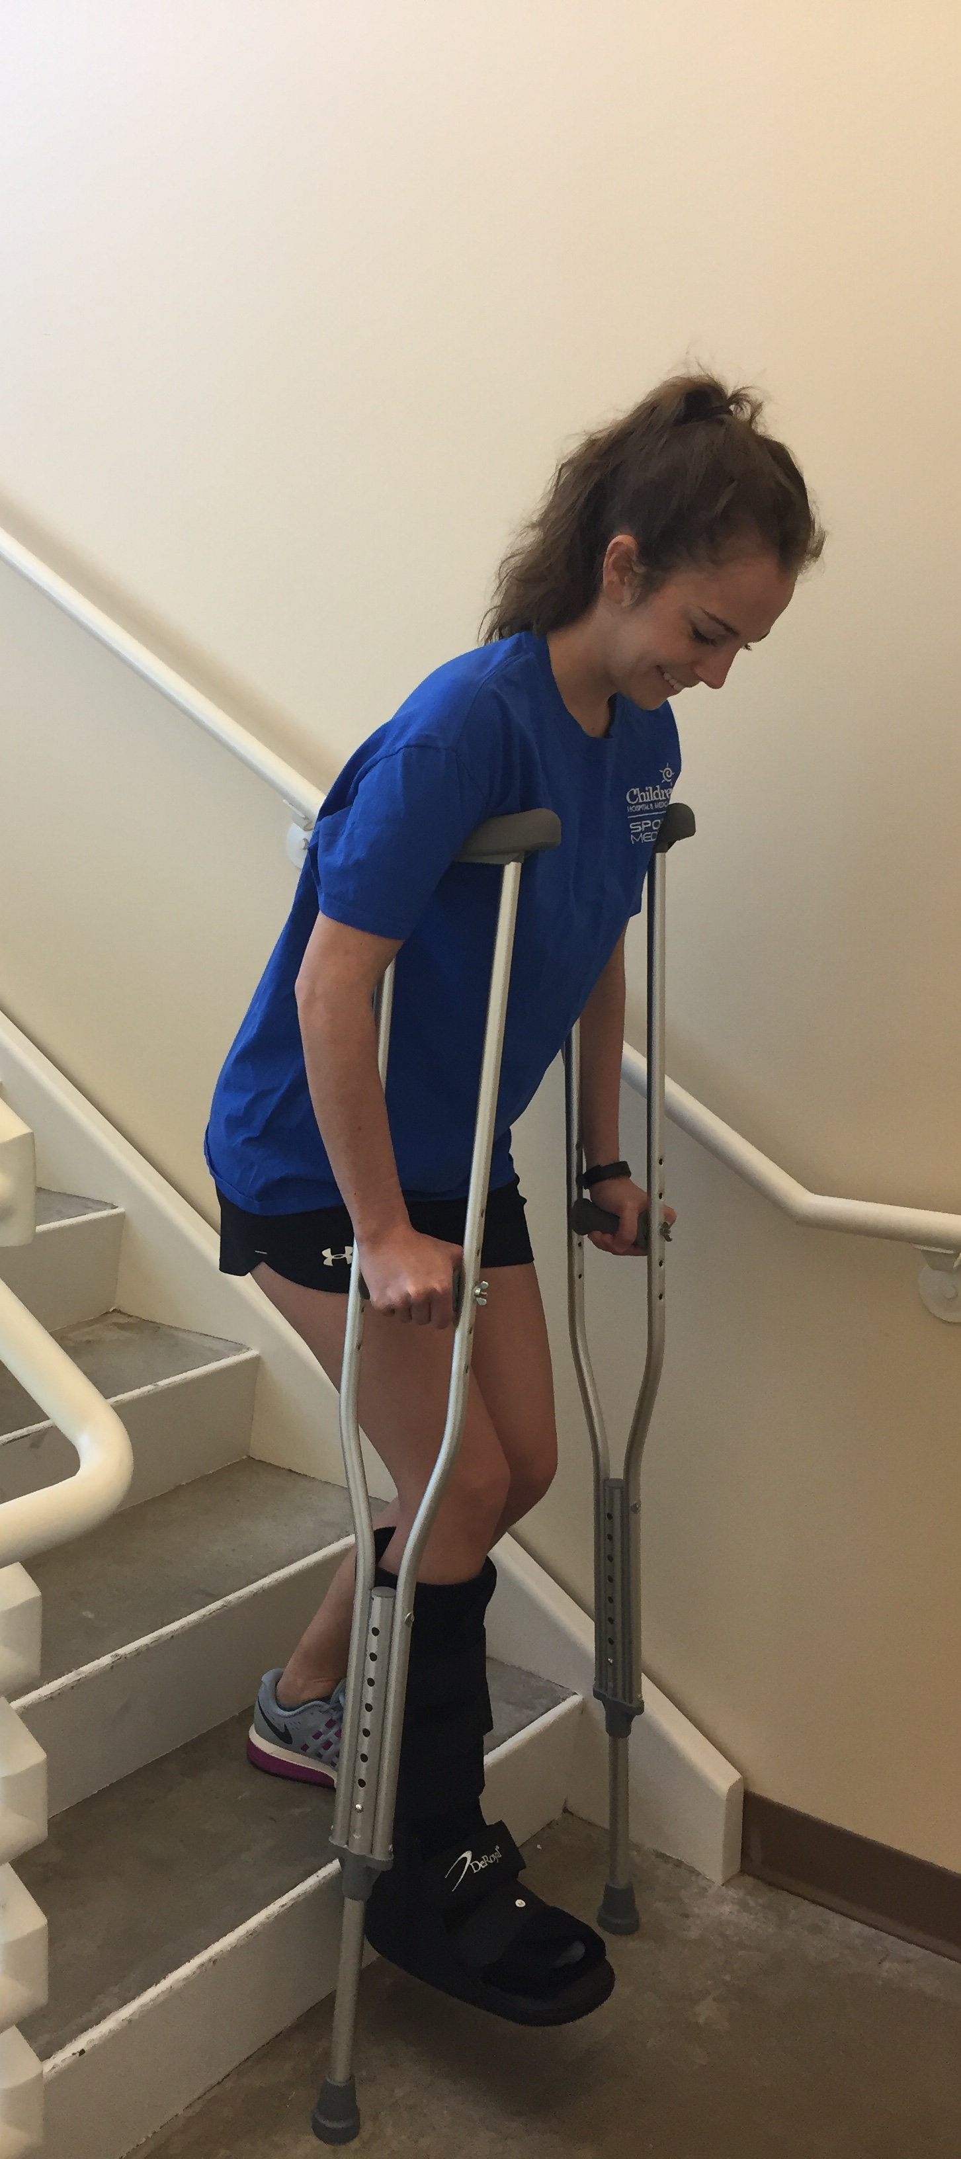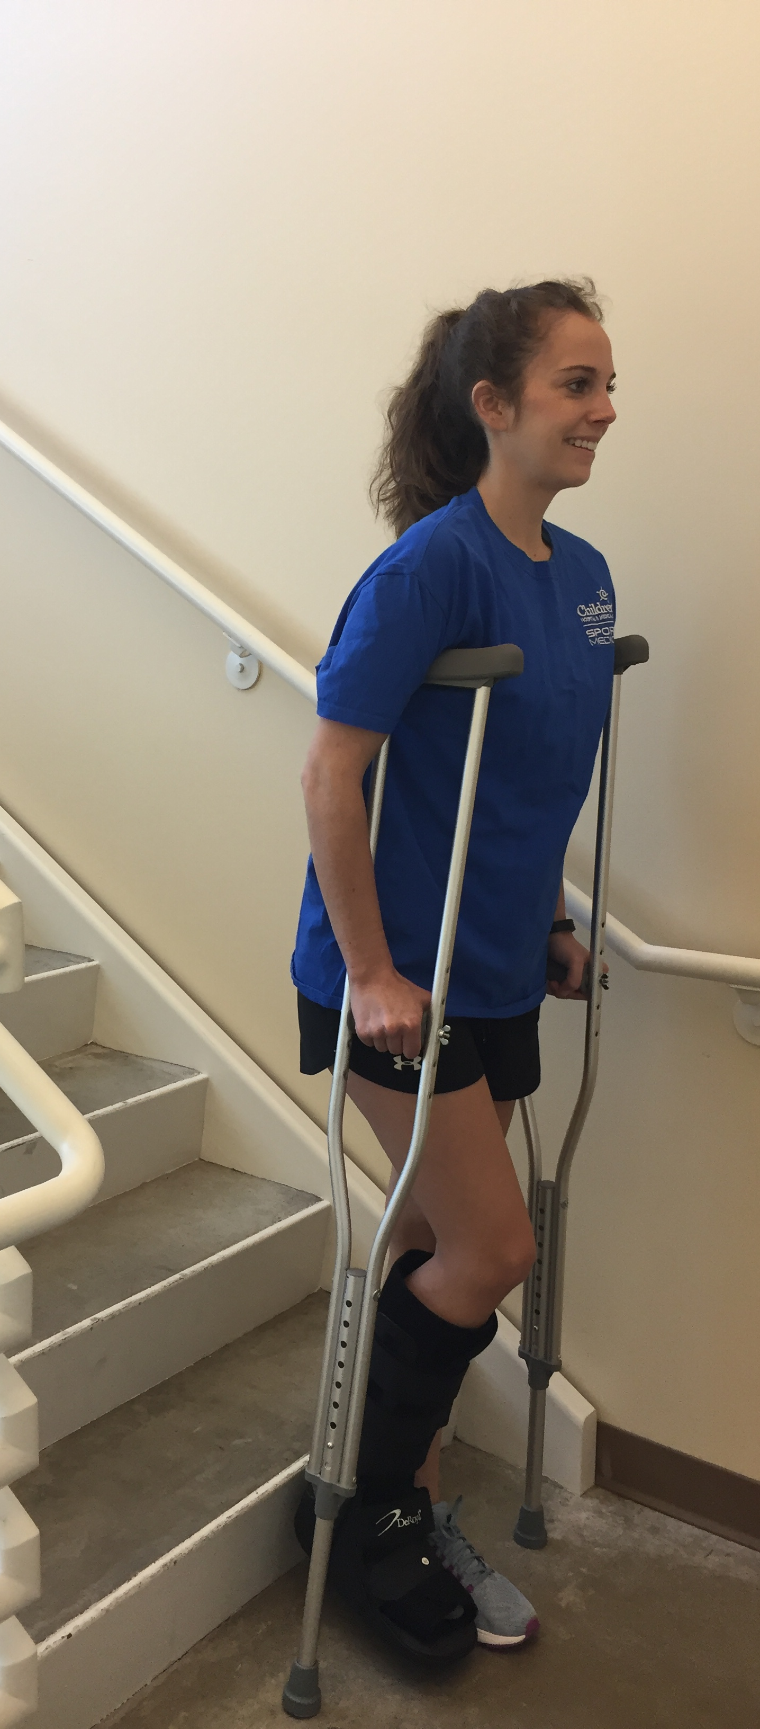
your body.
- Place the crutches on the step below, followed by
the “bad” leg, then the “good” leg.
- Be sure to bend at the hips and knees to prevent leaning
too far forward, which could cause you to fall.
- If a handrail is available, place both crutches in hand on
unaffected side with rail on affected side. Advance hand
on rail slightly and place crutches on lower stair.
- Take one step at a time.
- Have someone in front of you to provide support

REMEMBER:
- UP with the GOOD first, DOWN with the BAD first! Crutches are ALWAYS DOWN FIRST!
- Use the crutches as prescribed by the physician and do not attempt to bear weight on injured leg until told to do so.

