Game Day Fueling Plan for Athletes

The Night Before Event
- Eat a high carbohydrate meal
- Be sure to drink plenty of fluids – NO CAFFIENE
- Get at least 7-8 hours of sleep
- Avoid foods that are unfamiliar or have spices/seasoning that are not a normal part of their diet.

Sample Menu for Night Before Event

Teriyaki chicken rice bowl  - 1-2 cups brown rice  - 4-6 oz chicken  - Mixed vegetables  - Low fat milk | Spaghetti and meat sauce  - 1-2 cups whole wheat pasta  - 1 cup spaghetti sauce  - 3-4 oz lean meat  - Italian bread  - Salad with low-fat dressing | Soft tacos  - 3-4 whole wheat tortillas  - 1-2 cups rice  - 3-4 oz lean ground meat or grilled chicken  - Cheese, lettuce, tomato

Sample Evening Snack for Night Before Event

Peanut butter sandwich | Low-fat popcorn | Yogurt parfait
Pretzels with string cheese | Cereal with milk | Trail mix or granola bar
Banana and peanut butter | Crackers and cheese | Fruit

Pre-Game Meal
- 3-4 hours prior to event
- Eat a meal high in whole grain carbohydrates, lean protein, and healthy fat.
- Should be foods that are familiar and easy to digest
- Be sure to have at least 20 ounces of fluids (avoid caffeinated beverages)
- Desserts like ice cream or a fruit pie are better than cake or anything that is all sugar

Sample Pre-Game Meals

Grilled chicken  - 3-4 oz grilled chicken  - Sweet or baked potato with toppings of choice (watch high fat choices)  - 1 cup vegetables | Grilled fish  - 3-4 oz grilled fish  - 1-2 cups mashed potatoes  - 1 cup vegetables | Sandwich  - 3-4 oz ham, turkey, chicken or roast beef sandwich on whole wheat bread with cheese  - Baked Lays or pretzels
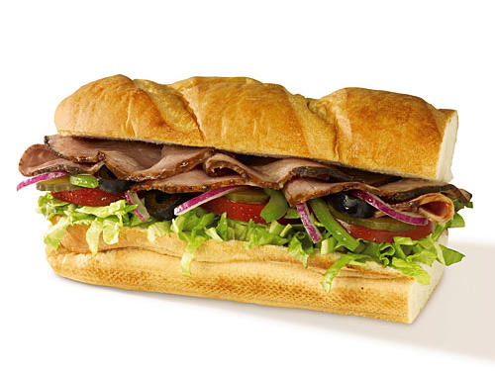
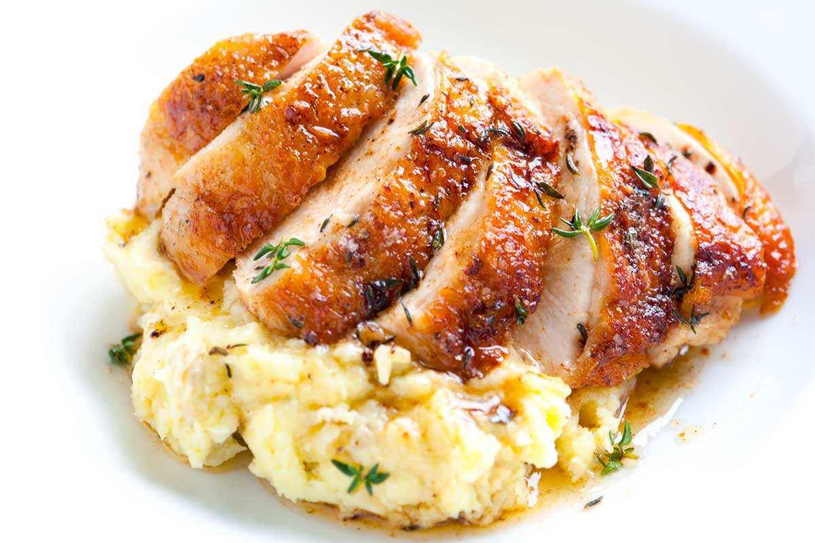
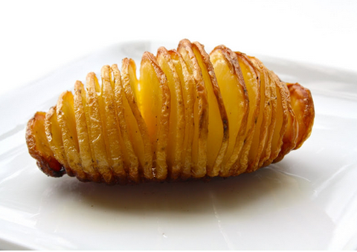
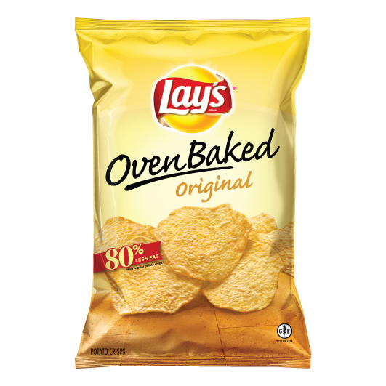

1 Hour Before Game
- Be sure to have snack high in carbohydrate
- Avoid foods that are high in protein or fat (they take a while to digest and may upset your stomach)
- Drink another 8-10 oz of water
- Ideas for snacks:
  - Peanut butter sandwich
  - Pretzels or crackers
  - Fruit
  - Granola bar
  - Low-fat yogurt

Game Time
- Try to drink 4 oz of cold water every 15-20 minutes of participation
- For continuous activity lasting longer than 60 minutes drink 20-32 oz of a diluted sports drink for every hour of exercise to keep fuel stores and electrolytes balanced

Post-Game
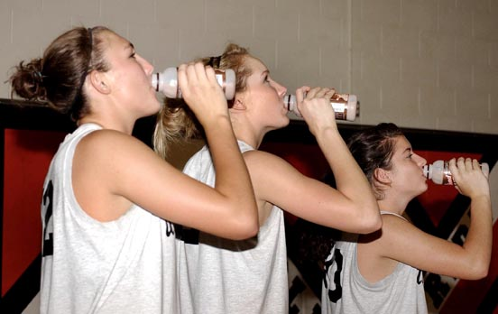
- For optimal performance, remember the Three R’s:
Refuel -> As soon as you able after exercise; within 15-60 minutes
Rehydrate -> Drink fluids with some carbohydrate in them
- Chocolate milk
- Gatorade
Replenish -> Have a well-balanced meal 1-2 hours following exercise

Sample Post Game Meals

Waffles, Pancakes  - Butter, syrup  - Peanut butter  Eggs-Omelet  - With veggies  - Meat  Potato  - Wedges  - Light home fries | Spaghetti and meat sauce  - 1-2 cups whole wheat pasta  - 1 cup spaghetti sauce  - 3-4 oz lean meat  - Italian bread  Salad with low-fat dressing  Pizza | Whole wheat pita  - 3-4 whole wheat tortillas  - 1-2 cups rice  - 3-4 oz lean ground meat or grilled chicken  - Beans  - Cheese, corn, lettuce, tomato

For more information visit:

Academy of Nutrition and Dietetics www.eatright.org
Moms Team Institute of Youth Sports Safety www.momsteam.com/nutrition

As an added resource, the staff at Children’s Sports Medicine is available to diagnose and treat sports-related injuries for youth and adolescent athletes. To make an appointment, call 402-955-PLAY (7529).

