LITTLE LEAGUE SHOULDER

What is it?

Little league shoulder is an injury to the growth plate in the proximal humerus (upper arm bone). It is typically caused by repetitive stress or micro trauma to the shoulder area. This is commonly seen in adolescent baseball pitchers as well as any athlete who uses an overhead motion on a regular basis, such as tennis and volleyball players. This stress to the growth plate is usually seen in the young growing athlete between ages 11-18. Once the athlete stops growing and the growth plates are closed the likelihood of this type of injury decreases.

What are the Signs and Symptoms?

This injury is often characterized by a gradual onset of pain in the throwing shoulder. Common signs and symptoms include:
- Tenderness over the area of the top of the shoulder
- Focused pain with a throwing or serving motion
- Pain can be felt for hours to days after throwing
- In pitching, pain worsens in the late cocking or deceleration phases
- May be associated with decreased velocity and control of pitches or serves in tennis and volleyball
Causes & Risk Factors

There is typically no one traumatic event that causes this injury. This injury is commonly found in patients that throw 4-5 days a week on average. Risk of little league shoulder increases with throwing too much at a young age. It is more common in adolescents who have a lack of muscle strength in the shoulder and upper back.
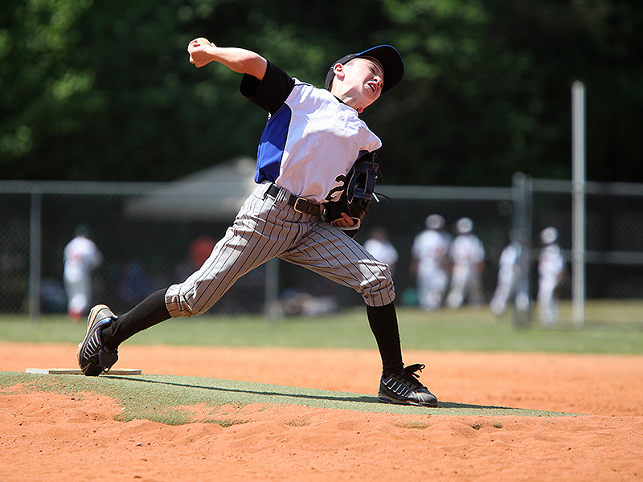

Other risk factors include:
- Not following pitch count guidelines
- Not allowing rest between heavy throwing sessions
- Throwing breaking/curve balls at too early of an age
- Increased high loads of torque
- Not properly warmed up prior to pitching
- Throwing through pain

Treatment & Outcomes

Initial treatment may consist of non-steroidal anti-inflammatory medications (i.e. ibuprofen) and ice to relieve pain. The most important treatment for this condition is rest. A physician may recommend a prescribed amount of rest in order to allow for proper healing and restoration of normal arm function. The healing process may take several months. For severe cases sometimes a sling will be provided to completely alleviate stress to the shoulder. Once symptom free, it is important that a graduated throwing progression be followed. This progression allows for slow, increased increments of stress reintroduced to the growth plate. If too much stress occurs too quickly – the symptoms are likely to return. With proper treatment, there is usually no permanent disability associated with this injury.

Injury Prevention

Some basic precautions can go a long way in preventing this type of overuse injury. Consider the following:
- Appropriately warm up by running, stretching and an easy gradual throwing progression.
- Pitchers rotate to other positions that don’t require hard throwing. (ie: 1st /2nd base)
- Maintain appropriate conditioning of the arm, core and hips through year round fitness
- Maintain appropriate core strength and lower extremity flexibility (especially the hip flexor)
- Follow recommended pitch counts for pitchers (see below)
- Take active rest days to perform physical activities other than throwing (see below)
- Avoid throwing and pitching through discomfort and pain
- Avoid pitching on multiple teams with overlapping season
- Use proper throwing and pitching techniques – emphasize control, accuracy and good mechanics
MAXIMUM PITCHING LIMITS
AGE | PER DAY | PER WEEK | PER SEASON | PER YEAR
7-8 | 50 | 75 | 1000 | 2000
9-10 | 75 | 100 | 1000 | 3000
11-12 | 85 | 125 | 1000 | 3000
13-16 | 95 | * | * | *
17-18 | 105 | * | * | *

DAYS OF REST REQUIRED FOR PITCHES THROWN IN A DAY
AGE | 0 DAY REST | 1 DAY REST | 2 DAYS REST | 3 DAYS REST | 4 DAYS REST
14 & Under | 1-20 | 21-35 | 36-50 | 51-65 | 66+
15-18 | 1-30 | 31-45 | 46-60 | 61-75 | 76+

Information and Guidelines adapted from the following:
- Little League® Baseball & Softball, 2010
- Policy Statement for Baseball & Softball, American Academy of Pediatrics, 2012
- Position Statement for Youth Baseball Pitchers, American Sports Medicine Institute, 2013

Consult your primary care physician for more serious injuries that do not respond to basic first aid. As an added resource, the staff at Children’s Sports Medicine is available to diagnose and treat sports-related injuries for youth and adolescent athletes. To make an appointment, call 402-955-PLAY (7529).

