Making Healthy Choices on the Road

Eating on the road, especially during competition and tournaments, is important and takes extra pre-planning. The extra effort is worth it to make sure your young athlete has the proper fuel for optimal performance, familiar foods to avoid stomach upset, and finally make sure the options are healthy and well balanced.

Think ahead when choosing a restaurant
- Know your menu terms and cooking terms
  - Healthy terms: broiled, baked, grilled, steamed, poached, roasted
  - Terms to avoid: fried, sautéed, crispy, creamy, rich, au gratin, battered, buttered, stuffed
- Stick with familiar restaurants or ones that serve food that the athlete is used to
- Look up the menu and try ordering ahead of time
- Don’t be afraid to ask questions and request substitutions
- High fat items could weigh you down or cause stomach upset which affects performance
  - Not optimal for recovery after a game or hard practice
- Healthy beverage choices
  - Stick to water, small glass of juice, or milk
  - Avoid caffeinated beverages like coffee, tea, or soda

Breakfast: Keep it simple

High Carbohydrate/Low Fat | High Fat Foods To Avoid
- Cereal (hot or cold) with banana and granola  - Scrambled eggs  - Bagels  - Waffles w/fruit and syrup  - English Muffins  - Low-fat muffins  - Pancakes  - Toast (whole wheat) or biscuits with nut butter and jelly  - Fruit/fruit juices  - Skim or low fat milk  - Yogurt | - Breakfast sandwiches made with cheese, sauce,  bacon, or sausage  - Side dishes (hash browns, etc.)  - Danish  - Croissants  - Biscuits and gravy

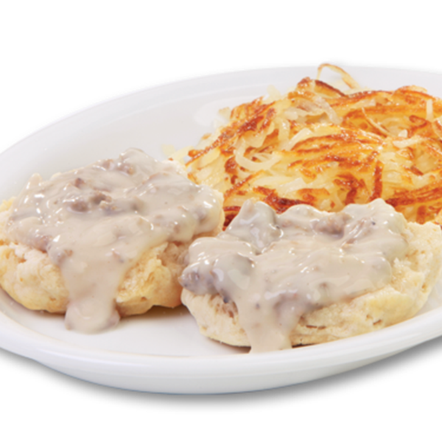
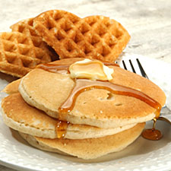

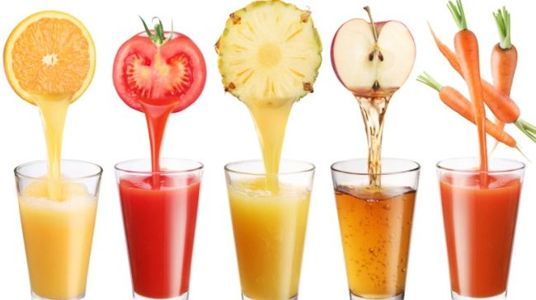
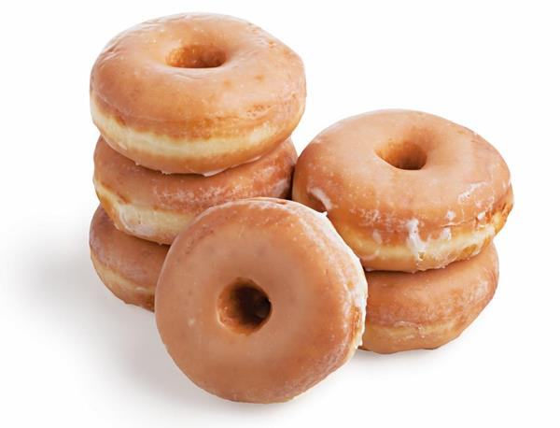

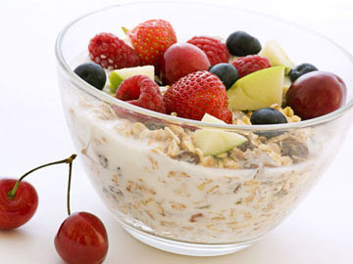
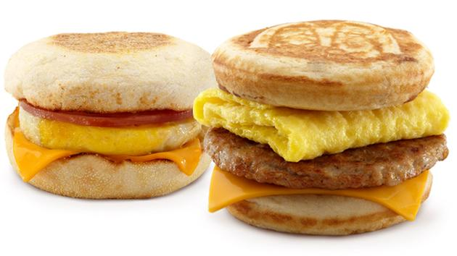

Lunch and dinner: It's what on top that matters! Often dressings, toppings, and condiments determine whether the meal is high carbohydrate, low fat or not.

Choose | Avoid
Burgers | Burgers
- Single  - Without "special sauce" (ketchup or mustard are better)  - Without cheese  - Tomatoes and lettuce | - Double (if your athlete wants a double burger, get it without cheese)  - Super, deluxe or supreme  - With cheese and/or bacon  - Sauce
Pizza | Pizza
- Thin crust  - Vegetable toppings (mushrooms, spinach, onion, green/red peppers, hot peppers, pineapple, and broccoli)  - Leaner protein options (chicken, Canadian bacon, low-fat mozzarella or ricotta cheese) | - Thick crust  - Fatty meat toppings (pepperoni, sausage, bacon)  - Extra whole cheese
Sandwiches | Sandwiches
- Lean meat (roast beef, chicken, turkey, ham, plain tuna)  - Low fat cheese  - Spices (oregano, pepper)  - Mustard, ketchup, BBQ sauce  - Vegetables, pickles, hot or sweet peppers  - Roll, bagel, pita bread, tortilla, hearty grain bread | - Tuna or chicken salad (the mayonnaise adds fat)  - Mayonnaise  - Oil  - "Special" sauce  - Croissants  - Biscuits
Potatoes | Potatoes
- Baked with low fat toppings (nonfat sour cream, chives, grated cheese, mushrooms, broccoli, chili) | - French fries (if your athlete does have fries, get a small order, or, better yet, have them share an order with another player)  - High fat toppings (cheese sauces, regular sour cream, bacon
Soup and Salad Bar | Soup and Salad Bar
- Salad greens  - Fresh fruits and vegetables  - Plain pasta  - Lean protein toppings (low-fat cheese, low-fat cottage cheese, kidney beans, egg whites, plain tuna, chicken, turkey or roast beef)  - Low fat or nonfat salad dressings  - Broth-based soups (chicken/turkey with noodles/rice, minestrone, vegetable, any bean) | - Prepared salads (potato, macaroni, coleslaw; again it is the mayonnaise that adds the fat)  - Pasta with mayonnaise or oil  - Bacon bits  - Olives  - Blue cheese, regular salad dressings  - Cream-based soups (clam chowder, cream of mushroom, broccoli or asparagus)

For more information visit:
Moms Team Institute of Youth Sports Safety http://www.momsteam.com/nutrition
Academy of Nutrition and Dietetics www.eatright.org

Consult your primary care physician for more serious injuries that do not respond to basic first aid. As an added resource, the staff at Children’s Sports Medicine is available to diagnose and treat sports-related injuries for youth and adolescent athletes. To make an appointment, call 402-955-PLAY (7529).

