THE DIABETIC ATHLETE

Diabetes is a common metabolic disorder characterized by the inability of the pancreas to produce enough insulin. Diabetes does not have a cure, but it can be managed if the individual is careful with their diet, exercise program, and use of insulin (if needed).

Type 1 Diabetes Often referred to as juvenile onset diabetes because the onset usually occurs under the age of 25. There is no known cause for Type 1 diabetes. Typically the onset is sudden with symptoms occurring within a time frame of several days to several weeks. Type 1 Diabetics are insulin dependent and will need to rely on insulin on a regular basis to keep their blood sugar levels within a normal range.

Type 2 Diabetes This type of diabetes is the most common form. Most cases are linked to a family history of diabetes, obesity, and sedentary lifestyle. Onset of Type 2 Diabetes typically occurs after age 40. If this is recognized early it can be managed with a healthy diet and exercise program without the need for insulin.

Preparing for Exercise:
It is very important for athletes with diabetes to go through a pre-participation exam to gain clearance from their physician. Although it is likely that your physician will give you approval, it is a good time to learn about any changes in testing schedule, medication, or other things you need to think about for exercise and sports. The pre-participation exam also provides you with time to learn about sport specific diabetes precautions. Athletes with type 1 diabetes should have their glycosylated hemoglobin (HbA1c) evaluated every 3 to 4 months to assess their overall long-term glycemic control. These values are not used to determine the day-to-day decisions concerning sports participation. It is recommended that the athlete has an annual examination for retinopathy, nephropathy, and neuropathy along with a sensory function check in the foot and ankle reflexes. Exercise limitations or restrictions for athletes with diabetes related complications should be determined by the athlete’s physician.

Exercising with Diabetes:
Athletes with diabetes are encouraged to participate in all types of sports and activities. Balancing blood sugar levels by carefully monitoring their food intake, insulin levels, and activity level is the most important key for the diabetic athlete. Normal blood glucose levels range between 80-120mg/dL. Athletes should monitor their blood glucose levels before, during, and after activity to ensure their blood glucose levels stay within a normal range. Two problems that can occur is hypoglycemia (low blood glucose/sugar levels) or hyperglycemia (high blood glucose/sugar levels). Hypoglycemia can begin when the athlete is not eating enough carbohydrates prior to intense exercise and their blood sugar drops as a result. This can result in a condition called “insulin shock”. Hyperglycemia is when the athlete’s blood glucose gradually rises over time as a result of insufficient insulin. Hyperglycemia is the opposite of Hypoglycemia. This can result in a diabetic coma. The signs and symptoms of both of these conditions are found in the next table.

Hypoglycemia | Hyperglycemia
Dizziness | Fruity-smelling breath
Headache | Nausea/Vomiting
Intense Hunger | Labored Breathing
Pale and Clammy Skin | Dry Mouth
Confusion | Flushed Skin
Disorientation | Confusion
Physical Weakness | Unconsciousness Followed By Coma

Diabetes Care Plan:
Each diabetic athlete should have a diabetes care plan for all practices and games that their coach and athletic trainer should be aware of.

The following items should be included:
- Blood glucose monitoring guidelines- frequency of monitoring and pre-exercise exclusion values.
- Insulin therapy guidelines- type of insulin, dosages, and adjustment strategies for planned activity types.
- List of other medications- include those used to assist with glycemic control and/or treat diabetes-related conditions
- Guidelines for hypoglycemia recognition and treatment- prevention, signs, symptoms, and treatment.
- Guidelines for hyperglycemia recognition and treatment- prevention, signs, symptoms, and treatment.
- Emergency contact information- includes parents, other family members, and physician’s phone numbers. Also include consent for medical treatment.
- Medical alert tag- it is recommended that all diabetic athletes have a medical alert tag with them at all times.

Diabetic Supply Kit:
Supplies to treat diabetes-related emergencies should be available at all practices and games.
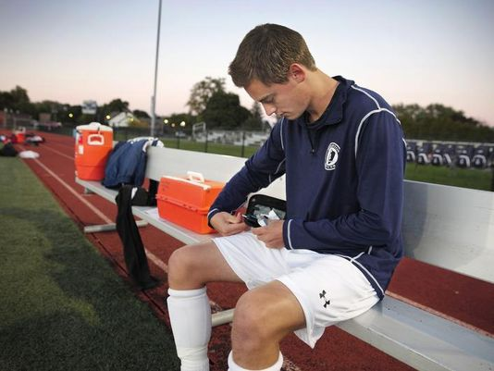
Below is a list of recommended items to have nearby.
- Copy of the diabetes care plan.
- Blood glucose monitoring equipment and supplies.
- Supplies to treat hypoglycemia
- Supplies for urine or blood ketone testing.
- Sharps disposal container
- Spare batteries for blood glucose meter and/or insulin pump.

Resources and for more information visit
American Academy of Pediatrics www.aap.org
Kids health www.kidshealth.org
American Diabetes Association www.ADA.org
www.SportsMD.com

Consult your primary care physician for more serious injuries that do not respond to basic first aid. As an added resource, the staff at Children’s Sports Medicine is available to diagnose and treat sports-related injuries for youth and adolescent athletes. To make an appointment, call 402-955-PLAY (7529).

