Fruitful 2021 COVID-19 Vaccine Campaign
Phase 1 (Orange): Social Strategy
Post 1
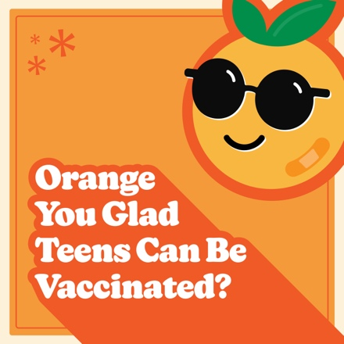
Facebook
You can’t knock the fact that the CDC recommends everyone 12 years and older get the COVID-19 vaccine. Do your part to protect your friends and community by getting vaccinated as soon as possible.

Learn more at @childrensomaha’s COVID-19 resource page: https://childrensomaha.org/covid

Instagram
You can’t knock the fact that the CDC recommends everyone 12 years and older get the COVID-19 vaccine. Do your part to protect your friends and community by getting vaccinated as soon as possible.

Visit ChildrensOmaha.org/covid for more information.
.
.
.
#covid_19 #covid #vaccinessavelives #nebraska #fruitful21

Post 2
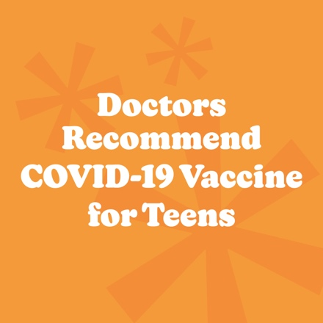
Facebook
The American Academy of Pediatrics recommends all youth 12 years and older be vaccinated against COVID-19. Getting vaccinated offers an added layer of protection for our school’s staff and students, families, and community.

Hear from @ChildrensOmaha doctors on how to help stop this virus.

Instagram
The American Academy of Pediatrics recommends all youth 12 years and older be vaccinated against COVID-19. Getting vaccinated offers an added layer of protection for our school’s staff and students, families, and community.

Hear from @ChildrensOmaha doctors on how to help stop this virus at ChildrensOmaha.org/covid.
.
.
.
#covid_19 #covid #vaccinessavelives #nebraska #fruitful21

Post 3
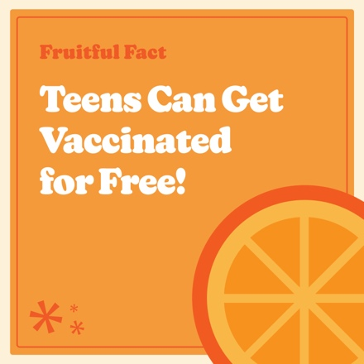
Facebook
Making sure youth ages 12 and older have a safe and successful school year starts with being vaccinated against COVID-19.

Anyone can get vaccinated for free, regardless of immigration or health insurance status. Squeeze the day by getting vaccinated as soon as possible.

Check out this article for more information:

Instagram
Making sure youth ages 12 and older have a safe and successful school year starts with being vaccinated against COVID-19.

Anyone can get vaccinated for free, regardless of immigration or health insurance status. Squeeze the day by getting vaccinated as soon as possible.

For more info about COVID-19 vaccines go to ChildrensOmaha.org/covid.
.
.
.
#covid_19 #covid #vaccinessavelives #nebraska #fruitful21

Post 4
Facebook
Let’s make it a fruitful school year by getting as many people vaccinated as possible.

Please do your part to protect against this potentially harmful virus by getting everyone 12 years and older vaccinated as soon as possible.

Learn more at @childrensomaha’s COVID-19 resource page: https://childrensomaha.org/covid

Instagram
Let’s make it a fruitful school year by getting as many people vaccinated as possible.

Please do your part to protect against this potentially harmful virus by getting everyone 12 years and older vaccinated as soon as possible.

Visit ChildrensOmaha.org/covid for more information.
.
.
.
#covid_19 #covid #vaccinessavelives #nebraska #fruitful21

