Fruitful 2021 COVID-19 Vaccine Campaign
Phase 2: Social Strategy
Post 1
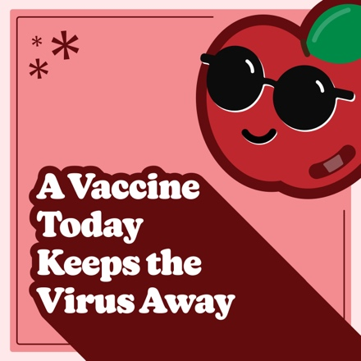
Facebook
Protect teenagers against COVID-19.

The CDC and American Academy of Pediatrics recommend that youth 12 years and older be vaccinated. Let’s pick good choices and make sure as many people as possible get vaccinated.
Learn more at @childrensomaha’s COVID-19 resource page: https://childrensomaha.org/covid
Instagram
The CDC and American Academy of Pediatrics recommend that youth 12 years and older be vaccinated.

Let’s pick good choices and make sure as many people as possible get vaccinated.

Visit ChildrensOmaha.org/covid for more information.
.
.
.
#covid_19 #covid #vaccinessavelives #nebraska #fruitful21

Post 2
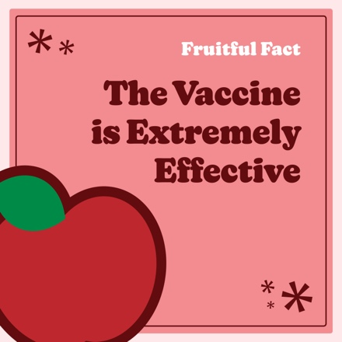
Facebook
A vaccine today keeps the virus away!
The COVID-19 vaccine can prevent nearly 100% of severe illness and death from the virus in healthy people.
Get more fruitful facts from the experts at @ChildrensOmaha at: https://www.childrensomaha.org/wp-content/uploads/2021/08/Fruitful-2021-Phase-2-Fact-Sheet.pdf
Instagram
A vaccine today keeps the virus away!
The COVID-19 vaccine can prevent nearly 100% of severe illness and death from the virus in healthy people. Get more fruitful facts from the experts at @ChildrensOmaha at ChildrensOmaha.org/covid.
.
.
.
#covid_19 #covid #vaccinessavelives #nebraska #fruitful21

Post 3
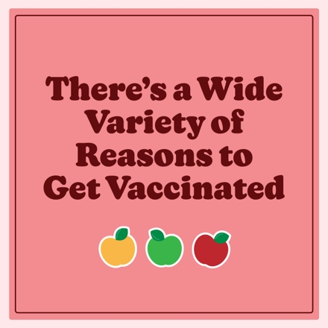
Facebook
There are a wide variety of reasons for teens to get vaccinated — to protect family, to protect younger children, to get back to activities like seeing friends, and making it a fruitful school year.

For more info on how to help friends and family find their reason for the vaccine, check out this article: https://www.childrensomaha.org/health-news/lets-talk-opening-up-about-the-covid-19-vaccine-with-friends-and-family/
Instagram
There are a wide variety of reasons for teens to get vaccinated — to protect family, to protect younger children, to get back to activities like seeing friends, and making it a fruitful school year.

For more info on how to help friends and family find their reason, visit ChildrensOmaha.org/covid.
.
.
.
#covid_19 #covid #vaccinessavelives #nebraska #fruitful21

Post 4
(Orange sticker as a GIF Graphic: “Orange You Glad I’m Vaxxed?”)
Facebook
We can make it a fruitful school year by vaccinating as many people as possible.

Share this graphic to show you’ve done your part by getting vaccinated. Together, we can end the pandemic, one vaccination at a time.

Learn more at @childrensomaha’s COVID-19 resource page: https://childrensomaha.org/covid

Instagram
We can make it a fruitful school year by vaccinating as many people as possible.

Share this post to your story to show you’ve done your part by getting vaccinated. Together, we can end the pandemic, one vaccination at a time.

Visit ChildrensOmaha.org/covid for more information.
.
.
.
#covid_19 #covid #vaccinessavelives #nebraska #fruitful21

